UID EX 10 ABINASH

240701007AIM:
The aim is to create interactive data visualizations, such as line charts and pie charts, for a fit tracker analysis system using JavaScript.

PROCEDURE:

Step 1:
Set up the HTML file to create the basic structure of the webpage. Include a canvas element to display the charts.

Step 2:
Add required libraries (like Chart.js) using CDN in the HTML file.

Step 3:
Create a JavaScript file (script.js) to store student data such as steps, count, and performance.

Step 4:
Use JavaScript to generate a line chart showing marks progression.

Step 5:
Create a pie chart to represent subject-wise performance distribution.

Step 6:
Link the JavaScript file to the HTML file and run the program in a browser.

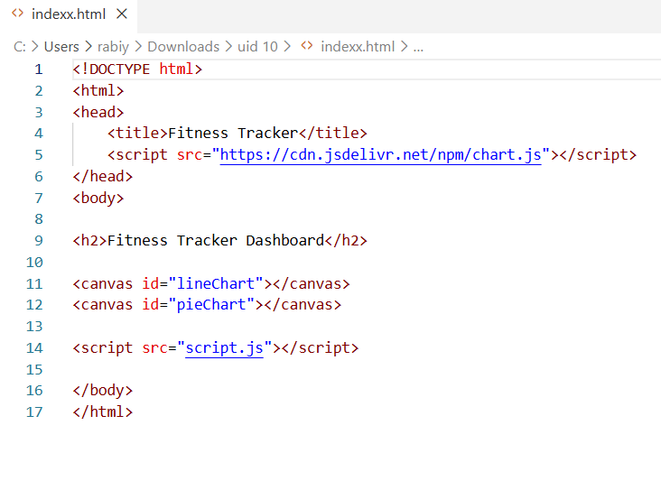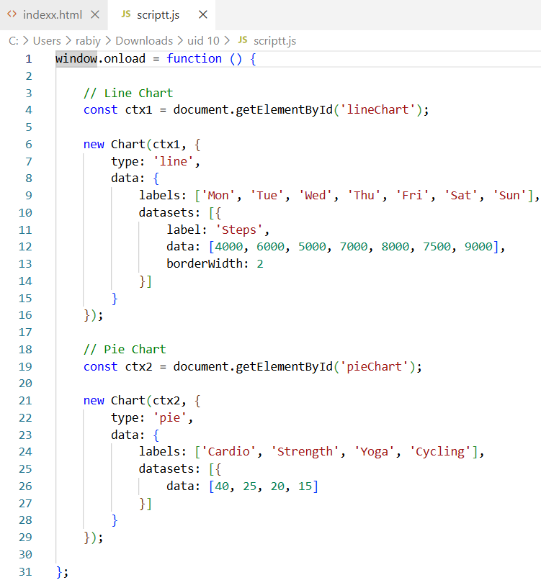

OUTPUT:
- A line chart showing steps over workout.
- A pie chart showing fit tracker distribution.
- 